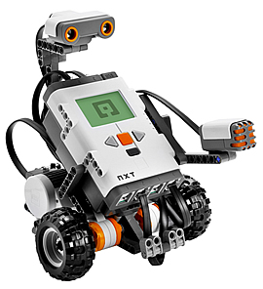
ARE YOU INTERESTED
IN ROBOTICS?
The St. Charles Robotics Team, will be holding a LEGO Robotics workshop this summer!
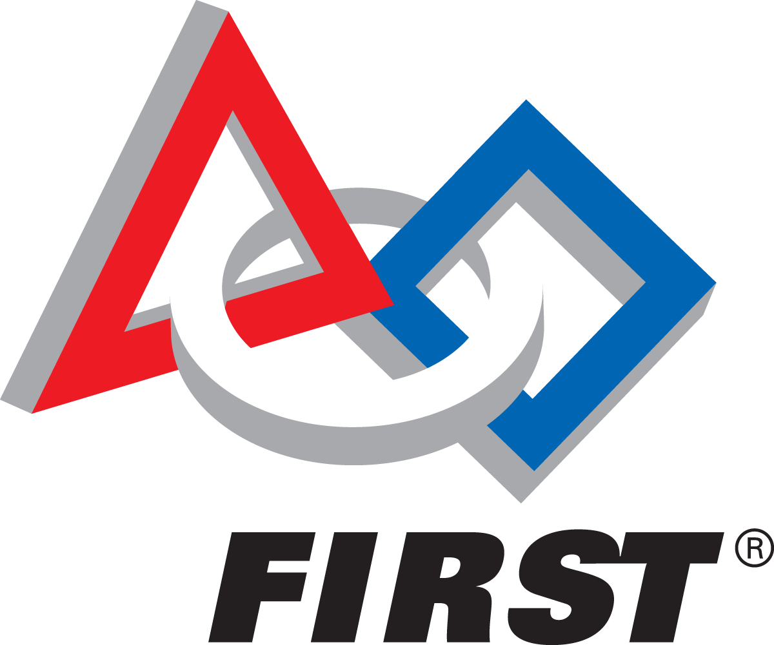
This workshop is open to all kids ages 9-12 and will be held in July
Details:
This workshop will be
held at PLACE
School from DATE
from TIME

A cost of $25 will be charged
to all participants to cover
food costs
For questions, please contact YOUR NAME HERE, with the subject “Robotics Workshop”
About the St. Charles Team
The St. Charles Robotics Team, team #4269 the “CardinalBots”, recently attended the FIRST World Championship in St. Louis. There, they finished within the top 100 teams, competing against teams from all around the world!

